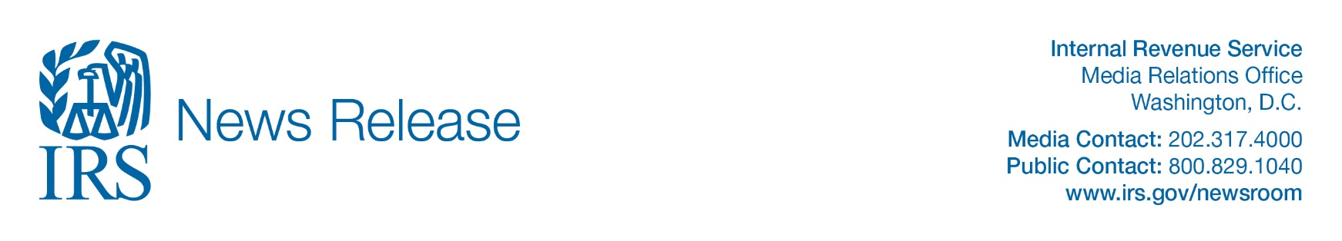

04 | 09 | 20

IRS urges taxpayers to use electronic options; outlines online assistance

IR-2020-68

WASHINGTON – The Internal Revenue Service today reminds taxpayers and tax professionals to use electronic options to support social distancing and speed the processing of tax returns, refunds and payments.

To protect the public and employees, and in compliance with orders of local health authorities around the country, certain IRS services such as live assistance on telephones, processing paper tax returns and responding to correspondence are extremely limited or suspended until further notice. All Taxpayer Assistance Centers remain temporarily closed as are many volunteer tax preparation sites until further notice. This will not affect the IRS’s ability to deliver Economic Impact Payments, which taxpayers will begin receiving next week.

Although the tax filing deadline has been extended to July 15, 2020, from April 15, the IRS continues to process electronic tax returns, issue direct deposit refunds and accept electronic payments. As of April 3, the IRS received over 97.4 million tax returns and issued over $213 billion in refunds.

IRS operational status and alternatives
Paper Tax Returns: All taxpayers should file electronically through their tax preparer, tax software provider or IRS Free File if possible. The IRS is not currently able to process individual paper tax returns. If you already have filed via paper but it has not yet been processed, do not file a second tax return or write to the IRS to inquire about the status of your return or your economic impact payment. Paper returns will be processed once processing centers are able to reopen. This year, more than 90% of taxpayers have filed electronically.

Ordering Forms: The IRS’s National Distribution Center is closed until further notice. We are not able to take any orders for forms or publications to be mailed during this time. Most forms and publications are available for download electronically at www.IRS.gov/forms.

Web Options: IRS.gov remains the best source for tax law questions, checks on refund status and tax payments. All IRS updates on the Economic Impact Payments and other Covid-19 related issues also will be posted immediately on www.IRS.gov/coronavirus. Taxpayers can check their refund status at Where’s My Refund? or obtain a tax transcript at Get Transcript Online. Tax transcripts are only available online at this time.

Taxpayers also can make tax payments through Direct Pay. Taxes due must be paid by July 15. The Interactive Tax Assistant can help answer tax law questions. There currently are no email options that will generate answers to questions posed by taxpayers. Publication 5136, IRS Services Guide, is a good source of information.

Telephone Options: Automated phone lines: which handle most taxpayer calls - also will remain available during this period. Some tax compliance lines also remain available. IRS phone lines supported by customer service representatives for both taxpayers and tax professionals are not staffed at this time. To check on regular tax refund status via automated phone, call 800-829-1954. (This line has no information on Economic Impact Payments.)

Practitioner Priority Service (PPS): Due to staff limitations the Practitioner Priority Service line is temporarily closed until further notice. The IRS is unable to process Centralized Authorization File (CAF) requests at this time.
IRS.gov remains the first option for answers to questions. Practitioners with e-Services accounts and with client authorization can access the Transcript Delivery System to obtain prior-year transcripts. Taxpayers should use Where’s My Refund? and Get Transcript, both common requests. However, the Get Transcript by Mail option should not be used since the offices that print and mail the transcripts are closed.
Taxpayer correspondence: While the IRS is receiving and storing mail, our mail processing functions have been scaled back to comply with social distancing recommendations. Currently, we have reduced responses to paper correspondence. Our primary concern is serving taxpayers as indicated in the People First Initiative, which includes numerous actions to alleviate taxpayer burden during this time.

Taxpayers who mail correspondence to the IRS during this period should expect to wait longer than usual for a response. Once normal operations resume it will take the IRS time to work through any correspondence backlog. Correspondence sent to IRS offices may be returned to the taxpayer if that office is closed and no one is available to accept them.

U.S. Residency Certification: The Philadelphia Accounts Management Campus is currently closed. Processing of the US Residency Certification Program is temporarily suspended. Normal operations will resume as soon as possible.

Taxpayer Protection Program: If you received correspondence from the IRS asking if you filed a suspicious tax return, you may use the online Identity Verification Service to validate your identity. Because the IRS cannot take calls or appointments right now, this is the only present option and is only for taxpayers who receive IRS letters asking them to authenticate their identity via online, telephone or in-person and confirm whether they filed the tax return in question.

-30-

